[Insert country name] |  |  | Date: [select the date]
Public Health Situation Analysis (PHSA) – Short-form
Initiated by: ☐ Country Office ☐ Regional Office ☐ HQ
Typology/ies of emergency | Main health threats | UN response level |  | WHO grade | Security level | INFORM risk (rank)
[Insert the images describing the type of the emergency, please use OCHA icons online (page 1 and 2)] | [Click and type a list of the threats e.g. communicable diseases, …]  List of pandemic, epidemic diseases | [Click here and type the UN level of response]  UN response levels online |  | [Click here and type the WHO grade]  WHO graded countries | [Click and enter text or table.]  UN security levels | [Click and enter risk score and global rank rank.] Inform Index
Summary of crisis & key findings |  |  |  | Map of affected Country/Region
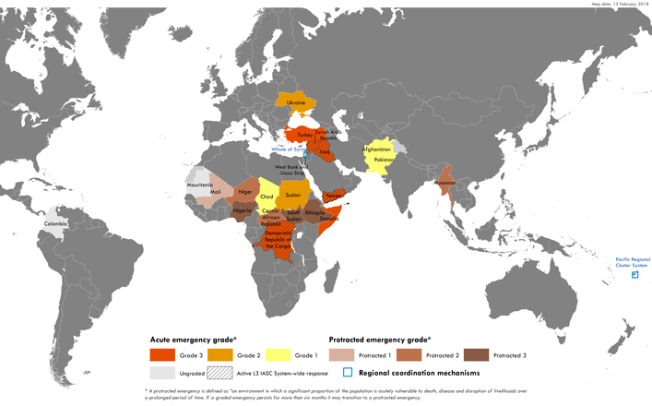
Replace the map
Humanitarian profile
 |  |  |  |  | 
xxx million | xxx million | xxx million | xxx million | xxx million | xxx million | xxx million
POPULATION  IN NEED  [Click to specify: disaggregated by sex and age if possible or population breakdown by age, gender, urban, rural] | POPULATION  IN NEED OF HUMANITARIAN HEALTH ASSISTANCE | DEATHS | INJURED | INTERNALLY DISPLACED PERSONS (IDPs) | RETURNEES | REFUGEES

Health status and threats
Population mortality

Vaccination coverage

Key Health Risks over coming month
Public health risk | Level of risk*** | Rationale
[e.g. AWD] |  | [Click here to enter text.]
[e.g. malaria] |  | [Click here to enter text.]
[e.g. ARI] |  | [Click here to enter text.]
[e.g. mental health] |  | [Click here to enter text.]
[e.g. injuries] |  | [Click here to enter text.]
***[Select cell and fill with the colour]

Red: Very high risk. Could result in high levels of excess mortality/morbidity in the upcoming month.
Orange: High risk. Could result in considerable levels of excess mortality/morbidity in the upcoming month,
Yellow: Moderate risk. Could make a minor contribution to excess mortality/morbidity in the upcoming month.
Green: Low risk. Will probably not result in excess mortality/morbidity in the upcoming month.

Endemic infectious diseases

Epidemic-prone diseases
Surveillance/early warning, alert and response capacity
Key diseases

Malnutrition and child health

Sexual and reproductive health

Tuberculosis and HIV

Non-communicable diseases (NCDs)

Trauma

Mental health

Determinants of health

Health system status & local health system disruptions
Key information on disruption of key health system components
  ACCESS TO HEALTHCARE |   DISRUPTION TO SUPPLY CHAIN |   DAMAGE TO HEALTH FACILITIES |   ATTACKS AGAINST HEALTH
(enter text here) | (enter text here) | (enter text here) | (enter text here)
Pre-crisis health system status

In-crisis health system status

Humanitarian health response
[NUMBER] | HEALTH PARTNERS
Health response coordination

Health actor response
[In cases where the 3/4Ws map is not available, to cover partner engagement the following may be useful:
- Mapping initial assessment coverage, to identify areas which are not covered
- Locations of EMTs, in-country health sector partner coverage (pre- and post- event).
- Expected deployments (vSHOC)
- Development partners (who may already have projects and/or experience), to fulfil the humanitarian-development nexus]

Information gaps / recommended information sources
 | Gap | Recommended tools/guidance for primary data collection
Health status & threats for affected population
Health resources & services availability
Humanitarian health system performance
Key references
Contacts
Health Cluster Coordinator
Health Cluster Information Management Officer
[Country name] Public Health Information Services Focal Point (WHO Geneva or RO)

